Paper Title

First Author^{1*}, Second Author¹, Third Author²

¹Authors' Affiliation, Address, City, Country
²Authors' Affiliation, Address, City, Country

*Corresponding author: e-mail@e-mail.com

Article history: Received: ............... Accepted: ...............

ABSTRACT

A clear and concise abstract should have no more than 300 words. The summary presents the basic objective, the material and the method of the study, the significant results and the conclusion. Do not provide detailed methodological details or references.

Key words: key word 1, key word 2, key word 3

Jel codes: ….; …

Introduction

Introduction should be a short overview explaining the reasons for the research of a certain scientific problem. Provide a relevant scientific background and the current state of knowledge. The introduction contains literature references of published papers relevant for the examined issue. This section should justify the novelty.
Finally, briefly mention the main aim of the work. As far as possible, please keep the introduction comprehensible to scientists outside your particular field of research.

Material and Methods

The Material and Method section should provide sufficient information which will enable other scientists to repeat the experiment at a different location. It is necessary to provide information on the material: the information should precisely define origin of the material, its physical properties, etc. If a device or an instrument for obtaining experimental results is used, it is necessary to state: the name of the device or instrument, the model, the name of the producer and the country of origin. If a scientifically recognized method was used, it is required to be stated in literature, instead of describing the phases of the applied method. If certain changes were made in a scientifically recognized method, it is necessary to provide original literature references which will support and justify the applied modifications. If statistical data processing software was used, the name and the version should be stated.
The Material and Methods can contain subtitles.

Subtitle
Write formulas in Word using the option Insert/Equation Tool (Formula 1). The symbols used in the formula should be explained. Example:

$G=\frac{N_{g}}{N_{s}}×100 (\%)$ (Formula 1)

where:
G – coefficient of gener
N_{g} - number of genera
N_{s} - number of species.

Results AND discussion
It should provide a concise and precise description of the experimental results, their interpretation, as well as the experimental conclusions that can be drawn. All the tables, graphs, figures and mathematical equations need to be numbered. All the tables, graphs, figures and mathematical equations must be referred to in the text, must contain all the information so as to be understandable separately from the text. The same data are not to be presented both with tables and graphs. The Results and Discussions can also be written as two separate section (depends on the author's wishes).
The Results and Discussion can contain subtitles.

Subtitle
All illustrations and tables should be inserted into the main text of the manuscript close to their first citation and must be numbered following their order of appearance (e.g., Figure 1, Table 1, Figure 2, Table 2, etc.). Each table/s and illustration/s must be mentioned in the text of the paper.
Table must have horizontal separation lines only; no vertical lines (Table 1). A table header row should be written in bold. The table legend should be given inside and at the end of the table (in the last row, 9 pt). Tables should be created in text processor - Microsoft Word (not typed as classic text or scanned).

Table 1. Table title
Title 1 | Title 2 | Title 3 |  | Title 4
Title 1 | Title 2 | Title 3 | Title 5 | Title 6 | Title 7
Entry 1 | data | data | +
Entry 2 | data | data
Entry 3 | data | data | +
Entry 4 | data | data
Entry 5 | data | data |  | + | +
Legend: + - present

All illustrations must be legible and clear (Figure 1, Figure 2).

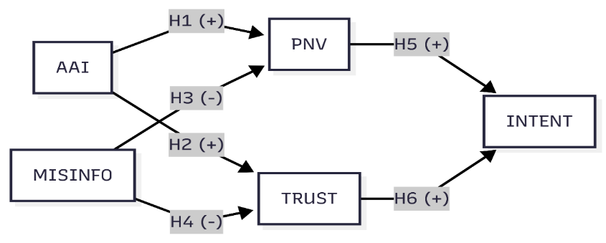
Figure 1. Title of figure

Subtitle
The discussion should not be merely repetition of the obtained results. Authors should discuss the results and how they can be interpreted from the perspective of previous studies and of the working hypotheses. The findings and their implications should be discussed in the broadest context possible. Future research directions may also be highlighted.

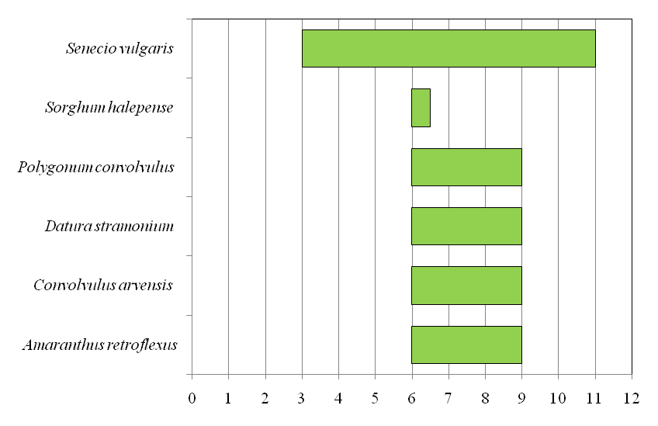
Figure 2. Title of figure

Conclusion

In conclusion, the author briefly stresses the most important viewpoints already stated in the text above. Conclusions must be clear, concise, not trivial and present real findings justified by the obtained results.

Authors' Contribution: Conceptualization: X.X. and Y.Y.; Methodology: X.X.; Software: X.X.; Validation: X.X., Y.Y. and Z.Z.; Formal Analysis: X.X.; Investigation: X.X.; Resources: X.X.; Data Curation: X.X.; Writing – Original Draft Preparation: X.X.; Writing – Review & Editing: X.X.; Visualization: X.X.; Supervision: X.X.; Project Administration: X.X.; Funding Acquisition: Y.Y.” All authors have read and agreed to the published version of the manuscript.

Funding (optional): All sources of funding of the study should be disclosed. In case the research presented in the paper was funded by a research project or some other institution, all detailed information about the funder should be provided (the name of the project, register number, duration of the project “from – to” and the full name of the institutions financing the project).

Data protection issues (optional): Research involving animals, human subjects or human data, must have been performed in accordance with the Declaration of Helsinki. Where applicable, the studies must have been approved by an appropriate Ethics Committee.
Example: “All experimental designs and protocols of this study were approved by the …” for studies involving humans or animals; OR “Not applicable” for studies not involving humans or animals.

Data availability statement: Please provide details regarding where data supporting reported results can be found, including links to publicly archived datasets analyzed or generated during the study. You might choose to exclude this statement if the study did not report any data. A ‘Data Availability Statement’ provides the details about the data's availability, including the DOI linking to it.
Example: “The data that support the findings of this study are openly available in [repository name] at [URL/DOI].” OR “The data presented in this study are available upon request from the authors.”

Acknowledgements: In case a submitted manuscript is a result of a research project, or its previous version has been presented at a conference in the form of an oral presentation (under the same or similar title), detailed information about the project, the conference, etc. shall be provided in Acknowledgements. Also, if person/s other than authors were involved in important aspects of the research project and the preparation of the manuscript, their contribution should be acknowledged in this section.
Example: “This work was supported by …” or “The authors express their gratitude to ...”

Conflict of interest: The authors declare that they have no conflict of interest.

References

The order of references should be arranged according to the alphabetical by author’s surname order without numbering. All references cited in the text of the paper must be listed in the References section, and vice versa. If the reference is in one of the languages other than English (e.g. Serbian, Croatian, Hungarian, Czech, Slovak, etc.), provide a translated title [in square brackets] following the original language title. Use the Food and Agriculture Organization of the United Nations citation style for the author–date referencing system (please see). Please, see the FAOSTYLE Citations Guide for more detailed information.
Examples:
Arnason, R. 1984. Efficient harvesting of fish stocks: The case of the Icelandic demersal fisheries. Vancouver, Canada, University of British Columbia. PhD dissertation.
Brosh, A. 2010. The alot is better than you at everything. In: Hyperbole and a Half. [Cited 6 February 2018]. https://hyperboleandahalf.blogspot.com/2010/04/alot-is-better-than-you-at-everything.html
Čanak, M., Parabućski, S. & Kojić, M. 1978. Ilustrovana korovska flora Jugoslavije [Illustrated weed flora of Yugoslavia]. Matica srpska.
DAISIE (Delivering Alien Invasive Species Inventories for Europe). 2018. [Cited 13 January 2025]. http://www.europe-aliens.org
Hisakata, R., Nishida, S. & Johnston, A. 2016. An adaptable metric shapes perceptual space. Current Biology, 26(14): 1911–1915. https://doi.org/10.1016/j.cub.2016.05.047
Hogue, C.W.V. 2001. Structure databases. In: A.D. Baxevanis & B.F.F. Ouellette, eds. Bioinformatics. Second edition, pp. 83–109. Life Sciences Series. New York, NY, Wiley-Interscience.
Law, E.P., Wayman, S., Pelzer, C.J., Culman, S.W., Gómez, M.I., DiTommaso, A. & Ryan, M.R. 2022. Multi-criteria assessment of the economic and environmental sustainability characteristics of intermediate wheatgrass grown as a dual-purpose grain and forage crop. Sustainability, 14(6): 3548. https://doi.org/10.3390/su14063548
Sambrook, J. & Russell, D.W. 2001. Molecular cloning: a laboratory manual. Third edition. Cold Spring Harbor, NY, CSHL Press.
Türközü, D. & Şanlıer, N. 2012. Gıdalardaki ağır metal kontaminasyonları: Güncel bakış. [Heavy metal contamination in foods: Current overview]. Selçuk Tarım ve Gıda Bilimleri Dergisi, 26(4): 73-80. https://dergipark.org.tr/en/download/article-file/3110732

